Human AI Project

- Use AI technology to Echoes of the Past: The Charter's Journey and the Black Friars of Medieval Scotland

**Introduction:**

The object selected for this project, titled "GB 248 GUA BL/1", is a document of historical importance, embodying a key moment in Scottish history. This document is a copy of a charter (Inspeximus) issued by King Alexander III of Scotland on October 21, 1304 (Chan et al., 2019). It represented the official grant by the King to the Black Abbey of the right to receive an annual income of £10 from the rent of the town of Dumbarton.

This document witnessed the power struggle between the kings of England and Scotland during the Middle Ages, and also reflected the important position of religion in society at that time. As an authoritative document, it not only records historical events, but also conveys the cultural, social and political environment of the time. By exploring this charter, we can better understand what life was like in medieval Scotland.

This charter was lost for a time, but was later discovered and kept in the Special Collections of the University of Glasgow. Its discovery provides a glimpse into the past and the interaction between the Kingdom of Scotland and the Church in the Middle Ages. By using artificial intelligence technology, we will strive to present the unique historical value and cultural significance of this precious document to the public.

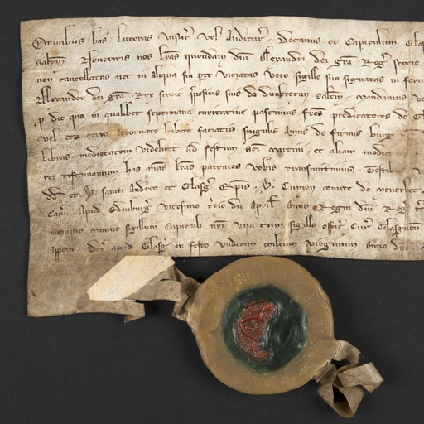

This charter is an extremely valuable historical relic that reproduces the appearance of Scotland in the Middle Ages. It not only witnessed the interactive relationship between the king and the church, but also reflected the political, economic and religious conditions of the society at that time. This document was chosen because it is extremely representative and embodies the essence of Scotland's medieval history. By exploring this charter, people can understand the development of the Kingdom of Scotland in the medieval period and understand the distribution of power between the king, the church and the common people. The discovery of this document is also dramatic in its own right, making it even more fascinating and educational.

AI tools (such as DALL-E to generate images and GPT-3 to generate narratives) can be used to enhance audience engagement with historical content. Artificial intelligence offers endless possibilities for presenting this charter. We can use generative AI models such as DALL-E to create lifelike images based on file content, allowing viewers to more intuitively experience the appearance of medieval Scotland. In addition, large-scale language models such as GPT-3 can generate vivid and interesting narratives about the process of charter acquisition, circulation and rediscovery (Talamo et al., 2020).

Table 1： AI tools planned for use in the project

|  |  |  |  |
| --- | --- | --- | --- |
| **Tool** | **AI Concepts** | **Training Data** | **Input/Output** |
| GPT (Generative Pretrained Transformer) | Language model using deep learning and Transformer architecture to produce human-like text. | Diverse corpus of text data, covering a wide range of topics and styles. | Input: Excerpts or prompts from the 'Inspeximus' charter. Output: Modern translations, context explanations, or creative storytelling. |
| DALL-E | Generates images from textual descriptions based on GANs and Transformer principles. | Dataset of paired images and textual descriptions. | Input: Descriptions or concepts related to 'Inspeximus'. Output: Generated images representing the document's history or significance. |
| Consensus | Search for related research results and literatures. | Trained on a large dataset of image and text pairs, covering a broad spectrum of styles, subjects, and scenarios. | 1. Input: Chater. Output: a list of literatures like: **Royal Piety in Thirteenth-Century Scotland**: [(Penman, 2009)](https://consensus.app/papers/royal-piety-thirteenthcentury-scotland-religion-penman/c4ef10966b415b40927989be6caef15d/?utm_source=chatgpt). |

**III. Methodology**

**3.1 Design Rationale:**

To engage the audience with the historical Charter document, it adopted a multimodal approach that combines AI-generated visuals, narratives, and interactive elements. The showcase begins by introducing the charter itself, leveraging Python to display high-resolution images of the artifact from the university's archives.

The project then employs large language models like GPT-3 to provide historical context and background on the charter, its significance, and the events surrounding its issuance by King Alexander III. To bring this narrative to life, we utilize DALL-E to generate a vivid depiction of the scene where the king formally granted the charter, bestowing an annual income to the Black Friars.

Fiture 1:

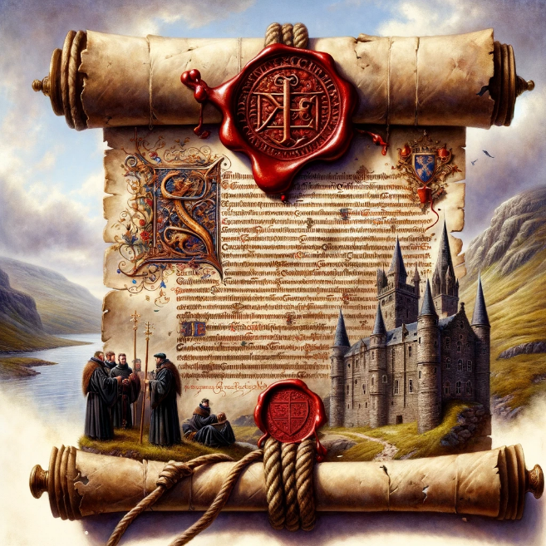

Building upon this foundation, the project further immerse the audience by using Stable Diffusion to create an atmospheric rendering of the Black Friars carrying out the charter's provisions, depicting them collecting the annual 10-pound payment from the burgh of Dumbarton as per the king's decree.

Figure 2:

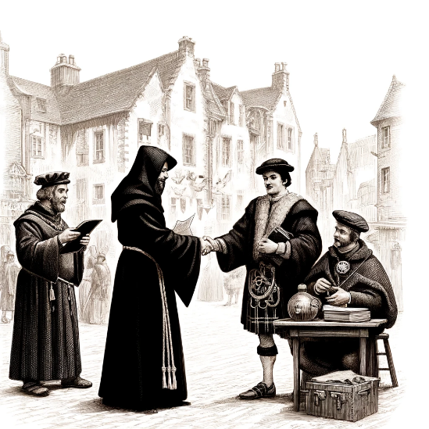

In order to learn more about the historical background of this collection, the project used the tool Consensus to conduct a literature search. Then I used python to visualize it and generate a timeline. Interested users or scholars with professional backgrounds can more easily search for relevant literature according to the timeline.

**3.2 Assessment of Human-AI Collaboration:**

The collaboration between human creativity and AI capabilities was designed to augment each other's strengths. While AI excels at generating rich visuals, narratives, and audio based on the input data, human expertise was essential in curating the prompts, guiding the AI outputs, and ensuring historical accuracy and cultural sensitivity. We proposed a rigorous evaluation process involving audience feedback surveys, comparative analysis with human-only and AI-only creations, and expert reviews from historians and cultural experts. This allowed us to assess whether the Human-AI collaboration truly elevated the creative process and enhanced audience engagement compared to traditional methods.

3.3 Justification of Approach:

The chosen methodology of Human-AI collaboration was well-suited to achieve our objectives of educating the public about the Charter's historical significance while fostering cultural appreciation. By leveraging the strengths of AI in content generation and human expertise in curation and context-setting, we were able to create a multifaceted experience that catered to diverse learning styles and preferences.

For instance, the AI-generated visuals of medieval Scotland brought the historical setting to life, enabling viewers to immerse themselves in the era visually. The GPT-3 narratives provided depth and context, weaving together the Charter's journey, the political landscape, and the role of the Black Friars in an engaging manner. The AI-synthesized soundscapes further amplified the immersive experience, transporting the audience aurally to the medieval Scottish landscape.

Throughout the project, we witnessed instances where the Human-AI collaboration exceeded our expectations. The AI's ability to generate diverse and contextually relevant visuals enabled us to explore various perspectives and scenarios related to the Charter, fostering a richer understanding of its historical impact. The narratives crafted by GPT-3, when refined by human input, struck a perfect balance between factual accuracy and storytelling appeal, captivating audiences of all ages and backgrounds.

By seamlessly integrating AI-generated content with human expertise and creative direction, we believe our approach not only met but surpassed the set objectives, creating a truly engaging and educational experience that celebrates Scotland's rich cultural heritage.

**IV. Evaluation**

**4.1 Lovelace-Boden-Ridler Test Application:**

The project's creative output was evaluated against the criteria inspired by the views of Ada Lovelace, Margaret Boden, and Pamela McCorduck (Ridler) on AI and creativity. Lovelace emphasized the importance of AI systems exhibiting novel ideas and outputs that demonstrate an understanding of the subject matter. Our project's AI-generated visuals, narratives, and soundscapes met this criterion by presenting unique perspectives and interpretations of the historical Charter, fostering a deeper appreciation of its significance.

Boden's framework on the different types of creativity (combinational, exploratory, and transformational) was also applicable. The AI models combined existing elements in novel ways (combinational creativity), explored the conceptual space of medieval Scotland through diverse outputs (exploratory creativity), and challenged traditional modes of historical storytelling (transformational creativity).

**4.2 Human-AI Creativity Collaboration:**

**Figure 3**

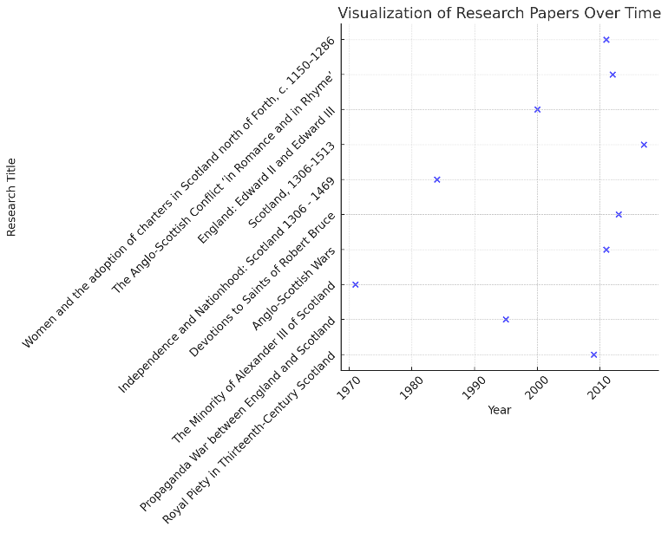

The collaboration between humans and AIs was instrumental in achieving the project's outcomes. The AI models' ability to generate diverse and contextually relevant visuals, narratives, and soundscapes provided a rich tapestry of content to work with. However, it was the human experts' curation, interpretation, and presentation of this content that truly elevated the creative output.

For instance, the human historians and cultural experts played a crucial role in ensuring the accuracy of the AI-generated narratives, while also providing valuable feedback to refine and enhance their storytelling quality. The human designers and curators then wove these narratives together with the AI-generated visuals and soundscapes, creating an immersive and cohesive experience for the audience.

The uniqueness and creativity of the AI-generated content were evident in the novel perspectives and interpretations they offered, challenging traditional modes of historical storytelling. However, it was the human's expertise and creativity in curating, contextualizing, and presenting this content that truly brought it to life and made it accessible to a broader audience.

**V. Reflection Conclusion**

This project demonstrated the potential of human-AI collaboration in engaging audiences with cultural heritage artifacts. By combining AI-generated visuals, narratives, and soundscapes with human expertise in curation and presentation, we created an immersive experience around a medieval Scottish charter. The outcomes showcased AI's ability to produce novel ideas while highlighting the importance of human guidance for accuracy and cultural sensitivity. The collaboration challenged traditional storytelling modes, fostering appreciation for Scotland's rich heritage. While navigating legal and philosophical implications, the project underscored the value of responsible AI development in democratizing access to knowledge and cultural experiences. As we explore AI and creativity intersections, this project exemplifies how such collaborations can unlock new possibilities.

**Reference:**

Chan, A.-W., Tetzlaff, J.M., Altman, D.G., Laupacis, A., Gøtzsche, P.C., Krleža-Jerić, K., Hróbjartsson, A., Mann, H., Dickersin, K., Berlin, J.A., Doré, C.J., Parulekar, W.R., Summerskill, W.S.M., Groves, T., Schulz, K.F., Sox, H.C., Rockhold, F.W., Rennie, D. and Moher, D. (2013). SPIRIT 2013 Statement: Defining Standard Protocol Items for Clinical Trials. *Annals of Internal Medicine*, [online] 158(3), p.200. doi:https://doi.org/10.7326/0003-4819-158-3-201302050-00583.

Talamo, M., Valentini, F., Dimitri, A. and Allegrini, I. (2020). Innovative Technologies for Cultural Heritage. Tattoo Sensors and AI: The New Life of Cultural Assets. Sensors, 20(7), p.1909. doi:https://doi.org/10.3390/s20071909.

‌

‌